# Operational Concept Description (OCD)

**Tour Conductor**

**Team No. 05**

|  |  |
| --- | --- |
| **Name** | **Role** |
| **Ankush H Prasad** | **System Architect , Project Manager, Prototyper/Builder** |
| **Ajay Kumar G C** | **Project Manager, Life Cycle Planner Prototyper/Builder.** |
| **Aadithya B K** | **Requirements Engineer, Prototyper/Builder.** |
| **Andrew Han** | **IIV & V, Quality Focal Point, Prototyper/Builder.** |
| **Joseph Mouawad** | **Operations Concept Engineer, Prototyper/Builder.** |
| **Manas Yadav** | **Feasibility Analyst, Prototyper/Builder.** |
| **Rohith Ravindra** | **Life Cycle Planner, Prototyper/Builder.** |

# Version History

| Date | Author | Version | Changes made | Rationale |
| --- | --- | --- | --- | --- |
| 10/13/2015 | JM | 1.0 | * Initial Version Draft | * Initial Version Draft |
| 10/19/2015 | JM | 1.1 | * Updated ER and business workflow diagram | * Update according to ARB feedback |
| 11/05/2015 | JM | 2.0 | * Fixed Program Model | * Program model was missing costs and benefits. |
| 11/15/2015 | JM | 2.1 | * Create tours and Take tours are not in your program model, but they are in your results chain as initiatives. | * Based on team members feedback. |
| 11/30/2015 | JM | 3.0 | * Modified the Capabilities Goals: deleted the Owner’s capability to give or withhold permission for tour creation; added the tour creator’s capability of viewing, editing, and deleting tours; added tour taker capability to navigate through the tour from stop to stop; and added tour taker capability to see the list of stops by swiping the screen from left to right. * Changed capabilities goals’ priority format from numbers to descriptive keywords such as “ Must have.” * Modified the program model by adding “Create Tours” and “Take Tours” to the initiatives. | * Based on discussions with client and change of requirement, and TA feedback. |

# Table of Contents

*Operational Concept Description (OCD) i*

*Version History ii*

*Table of Contents iii*

*Table of Tables iv*

*Table of Figures v*

*1. Introduction 1*

*1.1 Purpose of the OCD 1*

*1.2 Status of the OCD 1*

*2. Shared Vision 2*

*2.1 Benefits Chain 3*

*2.2 System Capability Description 3*

*2.3 System Boundary and Environment 4*

*3. System Transformation 5*

*3.1 Information on Current System 5*

*3.2 System Objectives, Constraints and Priorities 5*

*3.3 Proposed New Operational Concept 7*

*3.4 Organizational and Operational Implications 10*

# Table of Tables

**Table 1: The Program Model 2**

**Table 2: Level of Service Goals 6**

**Table 3: Relation to Current System** Error! Bookmark not defined.

# Table of Figures

**Figure 1: Benefits Chain Diagram for Web Crawler System 3**

**Figure 2: System Boundary and Environment Diagram of Web Crawler System** **4**

**Figure 3: Business Workflow of Current System 5**

**Figure 4: Element Relationship Diagram of Web crawler System 8**

**Figure 8: Business Workflow Diagram of Web Crawler System 9**

### Introduction

#### Purpose of the OCD

This document explores the shared visions and the value propositions of the stakeholders of the Tour Conductor project, along with the system’s objectives, constraints and priorities.

The success-critical stakeholders of the project are David Klappholz, as the project owner and maintainer; the Tour Creators and Tour takers, as users; and the members of Team 5, as developers.

#### Status of the OCD

The OCD is currently at version 3.0 As Built for package submission. We fixed the program model according to the latest feedback, and we modified the Capabilities Goals, based on discussion with the client and changes in requirements, by deleting the owner’s capability to give or withhold permission for tour creation, and added the tour creator’s capability of viewing, editing, and deleting tours. We also changed capabilities goals’ priority format from numbers to descriptive keywords such as “ Must have.”

### Shared Vision

Following is our Program Model that we used to identify initiatives and to facilitate designing and managing our project.

|  |  |  |  |
| --- | --- | --- | --- |
| **Assumptions:** People desire information of an area before they tour around the area | | | |
| **Stakeholders** | **Initiatives** | **Value Propositions** | **Beneficiaries** |
| * Tour creator * Tour taker * Developers * Maintainers * Client | * Design and develop the new system * Market the system * Create proper training for admin to create tours * Make user manual documentary * Create Tours * Take Tours | * Make it convenient for users to tour around any area * Help users find specific location in a certain area * Help the Cities(or other areas) to promote any touring route | * Tour creator * Tour taker |
| **Cost** | | **Benefits** | |
| * Development costs * Maintenance costs * Web hosting, domain name, and services(e.g google APIs) | | * Increase number of tour creators * Increase number of tour takers * Increase Number of tourists at significant locations | |

**Table 1: The Program Model**

#### Benefits Chain

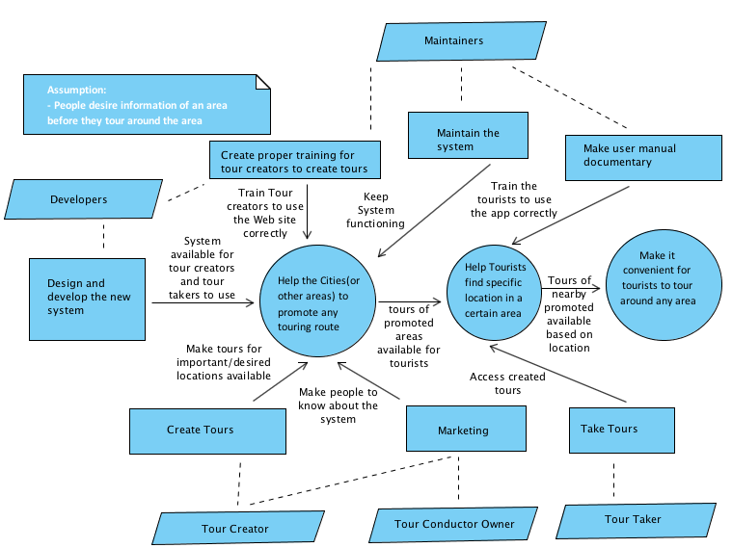

Figure 1: Benefits Chain Diagram for Tour Conductor.

#### System Capability Description

* The Goal of the Tour Conductor project is to allow people to conveniently tour places and areas. It also aims to help cities, schools, and other organizations (or even individuals) to better promote their areas. Thus, our target customers are such organizations and cities, along with all mobile phone users who are interested in touring certain areas.
* The system consists of two main application: a Web application that allow users (Tour Creators) to create tours, and a mobile application that allow users (Tour Takers) to take tours.
* The system uses Google Maps APIs, and therefore covers all the areas that the foregoing APIs covers.

#### System Boundary and Environment

All the services and functions that we will be developing or using can be summarized in the following system boundary and environment diagram.

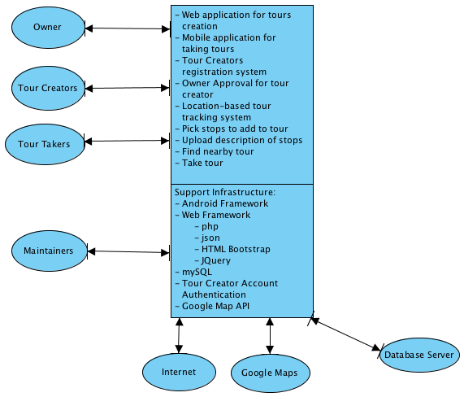

**Figure 2: System Boundary and Environment Diagram**

### System Transformation

#### Information on Current System

##### Infrastructure

There is no legacy system. We are building the project from scratch.

##### Artifacts

|  |  |
| --- | --- |
| **Artifact** | **Description** |
| **N/A** | **N/A** |

##### Current Business Workflow

N/A

#### System Objectives, Constraints and Priorities

##### Capability Goals

Tour Conductor will consist of a website that will allow tour creators to sign up for an account and create tours by picking specific stops in the area they want to promote, along with a mobile application that allows tour takers to take the created tours. Moreover, the owner must be able to approve and dismiss the created tours. If the owner approves a certain tour, the tour becomes available for tour takers on the Mobile app. Otherwise, the tour will be dismissed.

|  |  |
| --- | --- |
| **Capability Goals** | **Priority Level** |
| **OC-1: Tour Creator Sign-up:** Tour Creators are capable of creating accounts on Tour Conductor’s Website. | **Must Have** |
| **OC-2: Tour Creation:** Tour Creators are capable of creating tours of specific areas that they wish to promote on Tour Conductor’s Website. | **Must Have** |
| **OC-3: Location-Based Touring:** Tour Takers are capable of accessing and taking all tours of areas near their location, on Tour Conductor’s mobile app. | **Must Have** |
| **OC-4: Tag-based Location Search:** Tour Takers are capable of  searching tours areas according to specific tags describing the  desired areas, on Tour Conductor’s mobile app. | **Must Have** |
| **OC-5: View, Edit, and Delete Existing Tours:** Tour Creators are capable of viewing, editing, and deleting tours they have already created, on Tour Conductor’s website. | **Must Have** |
| **OC-6: Navigate through tour from stop to stop:** Tour Taker can take a tour by going from stop to another, using Google navigation, on Tour Conductor’s mobile app. | **Must Have** |
| **OC-7: Swipe through all stops on mobile screen:** Tour Taker can view the list of stops by swiping the screen from left to right, . | **Must Have** |

##### Level of Service Goals

|  |  |  |
| --- | --- | --- |
| **Level of Service Goals** | **Priority Level** | **Referred WinWin Agreements** |
| **LOS-1:** The system shall be user-friendly and intuitive. | Must Have | WC_3757 |
| **LOS-2:** The system shall render the searched tours correctly on mobile platforms. | Must Have | WC_3758 |

##### Table 2: Level of Service Goals

##### Organizational Goals

##### OG-1: Make it convenient for users to tour around any area

##### OG-2: Help users find specific location in a certain area

##### OG-3: Help the Cities(or other areas) to promote any touring route

##### Constraints

**CO-1:** **Android 4.0 as an Operating System:** The mobile application must work on Android 4.0 (ICS) and above.

**CO-3: Local Host as Web Server:** School and client are not providing web server.

##### Relation to Current System

N/A

#### Proposed New Operational Concept

##### Element Relationship Diagram

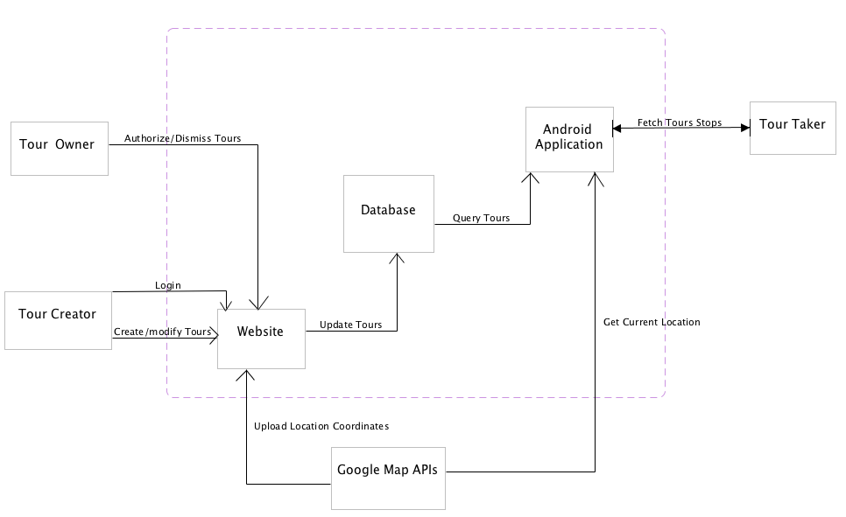

Figure 4: Element Relationship Diagram

##### Business Workflows

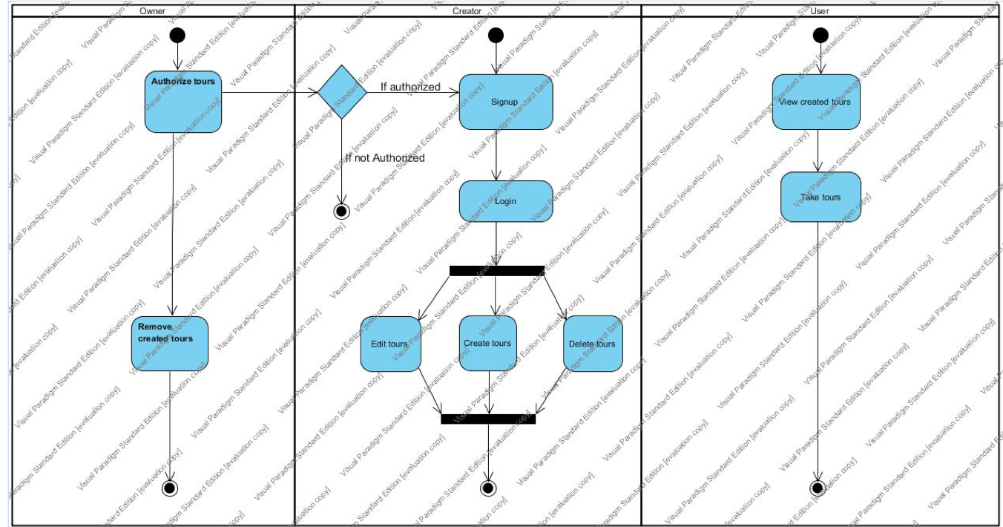

Figure5: Business Workflow Diagram of the Tour Conductor

#### Organizational and Operational Implications

##### Organizational Transformations

There is no current system. We are building a new system. However, from an organizational structure point of view, there will be an owner for the app, currently it is our client David Klappholz. He will also be the maintainer of the project. Our team is designing and developing the new system, and our roles are listed at the beginning of this document.